BREATHING – Occurs in Lungs

Inspiration – Inhaling
-Ribs move ______
-Diaphragm ________
-Chest cavity gets ________
-Air pressure inside _______

→ Causes air to move in
Expiration – Exhaling
-Ribs move _______
-Diaphragm curves ______
-Chest cavity gets ________
-Air pressure inside _______

→ Causes air to move out

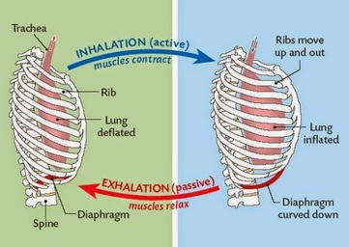

RESPIRATION – Occurs in Mitochondria

Process where ___________ from lungs (breathing) breaks down ___________ from the small intestine (digested food) to release __________________ after both being transported to the mitochondria of cells by the blood.

