Key Concept:
Human traits are controlled by dominant and recessive alleles, causing many different combinations of traits among a group of people.

Objectives:

- Students will be able to develop hypotheses about whether traits controlled by dominant alleles are more common than traits controlled by recessive alleles

- Students will be able to make observations and interpret data about certain traits controlled by dominant and recessive alleles in humans

Question or Problem:
Are traits controlled by dominant alleles more common than traits controlled by recessive alleles?

Procedure:

- Write a hypothesis reflecting your ideas about the problem.
- Using the photos of each of the traits listed in the data table, work with a partner to determine which trait you have. Circle that trait.
- Count the number of students in the class who have each of the traits listed in the data table. Record that number in your data table. Also, record the total number of students in the class.
- Calculate the percentage of the class that has each trait. Record percentages in the data table.

To calculate the percentages:

Number of students with trait ÷ Total number of students in class x 100 = Percent
(round to the nearest whole percent)

- Graph the percentages for each trait surveyed. (Make a bar graph)

Hypothesis:
_________________________________________________________________________________________________________________________________________________________________________________________________________________________________________________________________________________________________________________________________________________________

Photos of Traits:

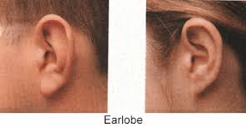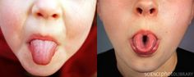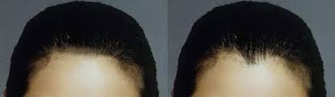
Free ear Attached ear Can’t roll tongue Can roll tongue No widow’s peak Widow’s peak

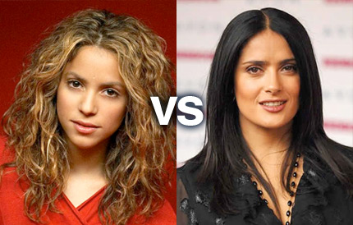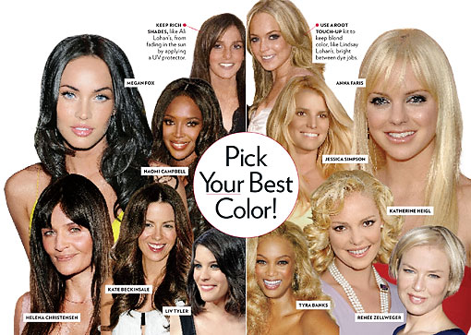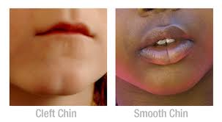
Curly hair Straight hair Brown or black Blonde or red Cleft chin No cleft chin
hair hair

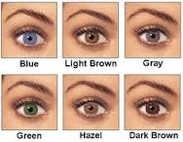
Pigmented skin Albino skin Dimples No dimples Eye Color

DATA TABLE
Total Number of Students in Class _____
 | Dominant Trait | Number of Students | Percentage of Students | Recessive Trait | Number of Students | Percentage of Students
A | Free ear lobes |  |  | Attached ear lobes
B | Roll tongue into a U |  |  | Can’t roll tongue into a U
C | Widow’s peak |  |  | No widow’s peak
D | Curly hair |  |  | Straight hair
E | Brown or black hair |  |  | Blonde or red hair
F | Cleft chin |  |  | No cleft chin
G | Pigmented skin |  |  | Albino skin
H | Smile dimples |  |  | No smile dimples
I | Brown, green, or hazel eyes |  |  | Blue or gray eyes

Analyze and Conclude:

- Which traits controlled by dominant alleles were shown by a majority of students?

- Which traits controlled by recessive alleles were shown by a majority of students?

- Based on the results, was your hypothesis supported by the data? Explain.

- Based on the results, does the percentage of people having a trait determine whether the trait is dominant or not? Give examples to support your answer.

