How does meiosis create variation in the population?

- Random Alignment –
Chromosomes from one parent line up with the chromosomes from the other parent that control the same trait.
However, chromosome pairs for each trait line up in random order.

- Crossing Over –
Further genetic variation comes from crossing over, which may occur during late prophase I of meiosis.
In late prophase I of meiosis, the chromosome pairs from the two parents that control the same trait can have sections of the chromosomes exchange. You can see that after crossing over, the chromosomes are neither entirely maternal (from mother) nor entirely paternal (from father), but contain genes from both parents. Crossing over occurs only in meiosis.

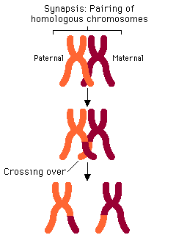

- Independent Assortment –
Chromosome pairs separate independently during the formation of reproductive cells. Each reproductive cell only receives one chromosome of the pair from each of the parents.

- Random Selection –
A reproductive cell from each parent is then randomly used to make the chromosome set for the offspring. This creates a blend of genetic material in the offspring.

