TYPES OF ASEXUAL REPRODUCTION

Label the following diagrams of types of asexual reproduction as binary fission, budding sporulation, regeneration, parthenogenesis or vegetative propagation.

Give two examples of organisms that use each method of reproduction.
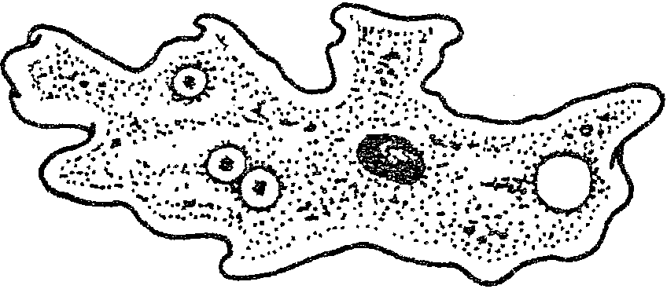  Binary Fission: Parent splits into 2 organisms and parent cell disappears.  Example: amoeba, paramecium | 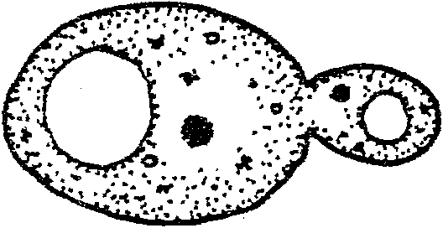  Budding: Small parts of parent split off but parent does NOT disappear.  Example: yeast – reproduces very quickly
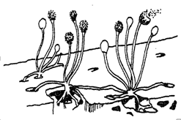  Sporulation: (spore formation) parent releases  spores – one parent, no fertilization  Example: bread mold, mosses, ferns | 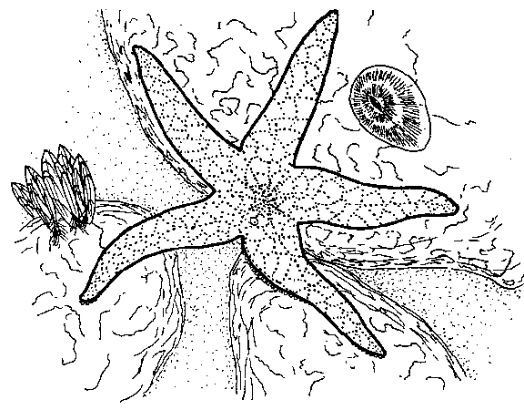  Regeneration: Pieces of parent split off and grow into new organism.  Example: starfish, earthworm, salamander (tail only)
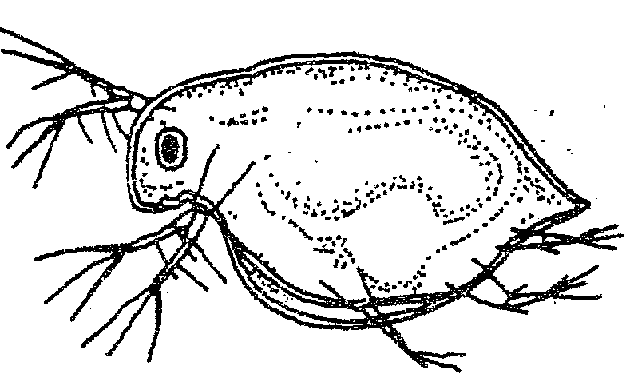  Parthenogenesis: Unfertilized cell grows into an  organism.  Example: daphnia, liverwort | 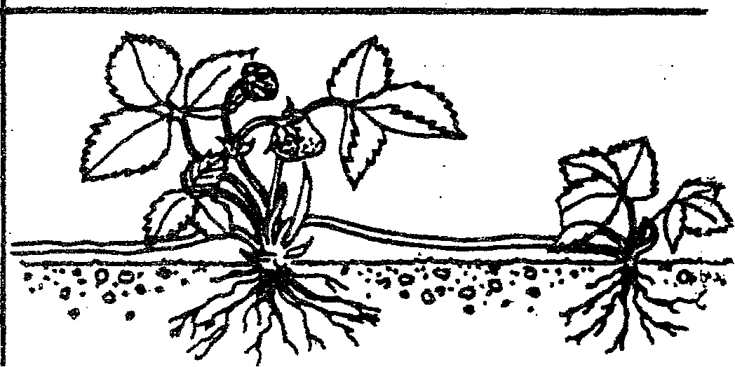  Vegetative Propagation: cuttings/underground  Stems  Example: coleus, pachysandra, poison ivy

